Titulo en español del artículo

Titulo en inglés del artículo

Nombre completo de autor 1
Afiliación institucional. País
Correo electrónico
ORCID

Nombre completo de autor 2
Afiliación institucional. País
Correo electrónico
ORCID

Nombre completo de autor 3
Afiliación institucional. País
Correo electrónico
ORCID

Resumen
El resumen debe estar compuesto por un máximo de 250 palabras y un mínimo de 150 palabras. Debe ser claro y exponer lo más relevante del artículo en cuanto a problema, metodología, resultados y conclusiones.

Community Water Supply and Sewerage System Administrative Associations (ASADAS) are essential entities in the provision of drinking water in rural and suburban areas of Costa Rica. However, many operate with limited technical and technological resources, relying on manual monitoring and facing difficulties in estimating non-revenue water. This article presents a general documentary synthesis of two IoT system implementation experiences developed in ASADAS: Playa Sámara de Nicoya and Paso Ancho y Boquerón. The methodology consisted of reviewing the existing documentation on both ASADAS and organizing the information into common categories: operational context, monitored variables, IoT architecture, communications, validation, and recommendations. The results show that the implemented solutions share architecture comprising measurement nodes, LoRa or LoRaWAN wireless communication, a gateway, a cloud platform, and a visualization dashboard. In Sámara, IoT ASADAS V1.0 devices were integrated for water monitoring and pumping control, with reported errors of 0% for volume and 0.73% for average flow rate. In Paso Ancho y Boquerón, a prototype for monitoring water level, flow rate, and volume was validated using a PLC, LoRa, Modbus, and ThingSpeak. It is concluded that these methodologies are replicable when supported by water audits, maintenance, training, and responsible data management.

Palabras clave
Incluir de 5 a 7 palabras clave separadas por punto y coma (;). Deben describir los elementos más importantes del artículo. Usar términos de tesauro del área válidos como el de la UNESCO http://vocabularies.unesco.org/browser/thesaurus/es/

Abstract
Traducción fiel del resumen en español, evitar el uso de traductores automáticos.

Las Asociaciones Administradoras de Sistemas de Acueductos y Alcantarillados Comunales (ASADAS) son entidades sin fines de lucro esenciales en el abastecimiento de agua potable en zonas rurales y suburbanas de Costa Rica. No obstante, muchas operan con recursos técnicos y tecnológicos limitados, como el monitoreo manual y dificultades para estimar agua no facturada. Este artículo presenta una síntesis documental, de carácter general, de dos experiencias de aplicación de Sistemas IoT desarrolladas en ASADAS: Playa Sámara de Nicoya y Paso Ancho y Boquerón. La metodología consistió en revisar la documentación existente sobre ambas ASADAS y organizar la información en categorías comunes: contexto operativo, variables monitoreadas, arquitectura IoT, comunicaciones, validación y recomendaciones. Los resultados muestran que las soluciones implementadas comparten un enfoque de nodo de medición, comunicación inalámbrica LoRa o LoRaWAN, puerta de enlace, plataforma en la nube y tablero de visualización. En Sámara se integraron dispositivos IoT ASADAS V1.0 para monitoreo y control de bombeo, con errores reportados de 0 % en volumen y 0,73 % en caudal promedio. En Paso Ancho y Boquerón se validó un prototipo para nivel, caudal y volumen mediante PLC, LoRa, Modbus y ThingSpeak. Se concluye que estas metodologías son replicables si se acompañan de auditoría hídrica, mantenimiento, capacitación y gestión responsable de datos.

Keywords
Traducción fiel de las palabras clave en español. Evitar uso de traductores automáticos.

Introducción
En esta sección del artículo se debe introducir los conceptos necesarios para identificar el problema o situación a resolver. Además, especificar el objetivo de la investigación.
Todas las ideas y conceptos deben estar fundamentadas con su correspondiente cita bibliográfica.
De ser necesario puede incluir otras sección o subsección antes de la metodología.

Drinking water provision comprises water collection, treatment, storage, and distribution to points of consumption. Costa Rica has achieved a high level of drinking water coverage. However, the sustainability and continuity of the service require adaptation to climate change, increasing demand, infrastructure deterioration, and unequal technical capacities among operators [3, 6, 9]. These conditions highlight the need to improve water management through accurate and reliable information to understand the status of water systems and support decision-making [9].

ASADAS and community water management

The Costa Rican Institute of Water Supply and Sewerage (AyA) is among Costa Rica’s institutions responsible for administering water resources and services [4, 5]. The tasks could be related to the administration of springs or wells, storage tanks, distribution networks, and disinfection facilities as well as the management of failures, maintenance, and coordination of services in collaboration with the community [3,5].

Approximately 28.7% of Costa Rica’s population receives their drinking water from ASADAS, which are mostly found in rural or suburban areas, and are responsible for the provision of many of the sources of water supply in the country [2-4]. Although ASADAS play an important role in the country’s economy, some limitations have been noted related to the lack of professional personnel, infrastructure, technologies and systematic gathering of data. Such limitations could result in inefficient monitoring of water losses, storage volume, flow rates and energy use [1-3, 7].

Non-Revenue Water and the Need for Monitoring

Non-revenue water (NRW) refers to the volume of water entering the supply system that does not generate revenue due to factors such as real losses—including leaks and overflows—apparent losses associated with metering errors, data-handling errors, or unauthorized consumption, and authorized consumption that is not billed [8].

In the context of ASADAS, bulk metering of water production and distribution, flow-rate recording, and water tank level monitoring provide the information required to prepare these assessments and guide maintenance and improvement actions [1, 2, 7]. The cases of Playa Sámara and Paso Ancho y Boquerón help define the operational problem addressed in this article. In Playa Sámara, pumping was scheduled manually at fixed intervals and had to respond to demand variations associated with tourism activities; mismatches between projected and actual demand resulted in overflows or the depletion of the main storage tank. In Paso Ancho y Boquerón, checking tank levels required traveling to areas with limited access, which reduced personnel availability for other tasks and delayed awareness of system conditions [1, 2]. Both situations demonstrate the need for accurate remote data to support service continuity, storage control, and water-loss assessment [1, 2].

The Internet of Things and Modular Architectures

In aqueducts with separate measurement modules and limited access to telecommunications infrastructure, LoRa provides a long-range, low-power wireless connection, while LoRaWAN™ establishes a network architecture in which nodes transmit data through a gateway to processing or storage services [13]. This architecture can also be integrated with level measurement systems, multipolar ultrasonic devices, industrial protocols, and cloud platforms to examine variables such as level, volume, flow rate, energy status, and signal strength [1, 2, 14].

In Playa Sámara, a system was implemented that connected ultrasonic devices, level sensors, and pumping control elements through IoT (Internet of Things) devices, LoRa communication, and the Adafruit IO platform. In Paso Ancho y Boquerón, a prototype was created using a PLC and LoRa communication; data collection was carried out through Modbus, with visualization in ThingSpeak. Although the projects were adapted to different infrastructures and needs, they shared the stages of diagnosis, variable definition, architecture design, node integration, transmission to a gateway, cloud upload and functional evaluation [1, 2].

Modular Architectures and Model-Based Systems Engineering

The digitalization of an aqueduct is not simply about incorporating sensors, but about transforming those data into useful information. The model proposed by A. J. Arguedas-Rodríguez et al. (2025) on IoT architectures for rural aqueducts points out that many proposals explain technological layers or case examples, but in many cases lack traceability between user needs, system functions, and physical components [3].

Model-Based Systems Engineering (MBSE) and the ARCADIA methodology provide a path to minimize this gap. To do so, they first describe what the organization should achieve without involving specific technologies; then, they define what the IoT system should provide; a logical architecture is built that does not depend on specific brands or platforms; and finally, a complete physical architecture is implemented with specific sensors, power supply, communications, and software. Separating these elements prevents solutions from becoming oversized, facilitates modularity, and makes it possible to understand solutions such as Sámara and Paso Ancho as variants of a general architecture.

Materiales y métodos (metodología)
En esta sección se debe describir de forma detallada la metodología de la investigación. Incluya tipo de investigación, lugar, población, tamaño de muestra, etc.

Resultados
Se deben describir los resultados obtenidos con la aplicación de la metodología descrita en la sección anterior. Debe apoyarse con cuadros y gráficos, los cuales deben estar debidamente citados en el texto y con numeración consecutiva. Recuerde justificar cada cuadro, ecuación y gráfico incluido, y evitar información redundante.

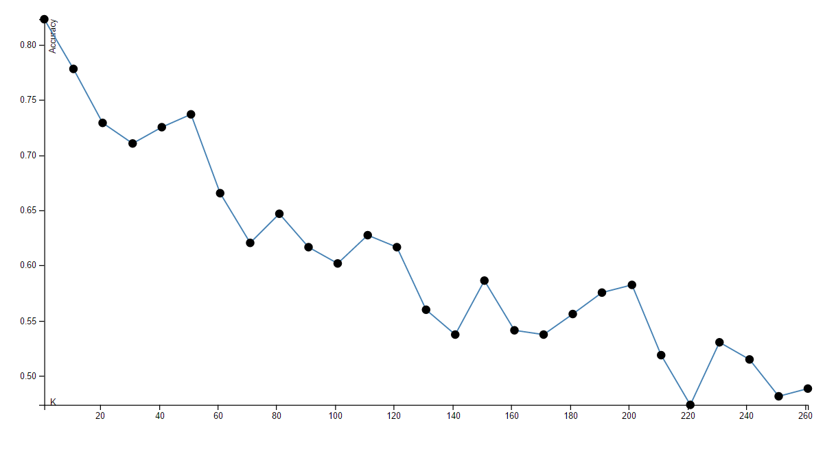
Figura 1. Descripción clara y concisa de la figura 1. Fuente: [1]

$\frac{B}{R_{a}}=θ_{0}J_{0}\left(\sqrt[b]{δ_{0}}\right)$ (3)

Cuadro 1. Descripción clara y concisa del cuadro 1.

 | Marzo 2017 |  |  |  | Marzo 2018
Parámetro | Promedio | Máximo | Mínimo | Desviación estándar | Promedio | máximo | Mínimo | Desviación estándar
DQO (mg/L) | 2 299,00 | 3 438,00 | 1 771,00 | 409,99 | 2 356,14 | 3 094,00 | 1 829,00 | 355,07
DBO₅ (mg/L) | 1 393,84 | 1 920,00 | 1 017,00 | 232,76 | 1 370,48 | 1 794,00 | 985,00 | 208,43
Aceites y grasas (mg/L) | 165,69 | 261,00 | 12,00 | 53,40 | 166,93 | 285,00 | 26,00 | 66,70
SST (mg/L) | 712,55 | 1 055,00 | 448,00 | 163,18 | 764,81 | 890,00 | 650,00 | 68,84
Ssed (ml/L) | 12,53 | 25,00 | 5,50 | 5,07 | 12,01 | 24,00 | 5,00 | 4,20
pH | 6,31 | 7,20 | 5,00 | 0,61 | 6,58 | 8,50 | 5,50 | 0,88

Fuente: [2]

Conclusiones y/o recomendaciones (discusión)
En este apartado se debe indicar las conclusiones y/o recomendaciones derivadas de los resultados obtenidos. También, se puede incluir un apartado de discusión donde se confirman o refutan resultados de acuerdo con la literatura existente. Deben ser claras y evidencias el aporte del artículo.

Agradecimientos
Esta sección es opcional y se debe incluir antes de las referencias.

Referencias

[1] G. Ramírez, E. Rico, A. Mercado, R. Ocampo, R. G. Guevara, G. M. Soto y H. Godoy, “Efecto del manejo cultural y sombreo sobre la productividad del cultivo del pepino (Cucumis sativus L.)”, Ciencia@UAQ, vol. 5, no 1, pp. 1-9, 2017.

[2] J. Lárraga-Gutiérrez et al. “Evaluation of a LED-based flatbed document scanner for radiochromic film dosimetry in transmission mode”, Physica Medica, vol. 47, pp. 86-91, 2018. https://doi.org/10.1016/j.ejmp.2018.02.010

